1. **ROBOT R1:**

* **Overall Dimensions (LxWxH) in** **mm:** 900 x 387 x 1250
* **Materials used:** Stainless steel AISI 304, PLA, Aluminium 6061 T4, ABS
* **Estimated weight:** 18kg

**Objective:** The main tasks of the R1 Robot is to receive the ball from R2 Robot, shoot the Lagori stack and the Ball on Head of the opponent’s seeker R2.

1. **Type of Drive:**

The R1 robot is housed on a 900mm×387mm **stationary chassis**. As per the team’s game plan, only R2 bot is being used for bringing the balls from the ball rack hence, there is no need for a dedicated drive train for R1. This also provides additional **stability**, **thus precision** to the shooting mechanism.

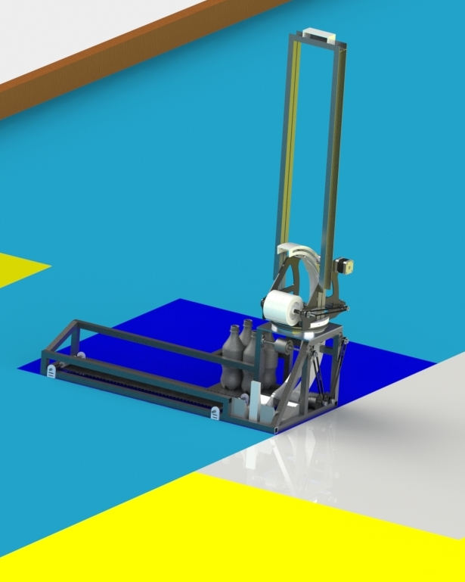

**Fig. 1: R1 Robot**

1. **Receiving mechanism:**

The **purpose** of the receiving mechanism is to receive the ball from R2 and transfer it to the loading mechanism. The balls are dropped on a 650 mm long conveyor belt which is driven by a [**Johnson Geared DC Motor [350 rpm]**](https://drive.google.com/file/d/1Jk_DCYbjCCyUdDuIL6Rs92Aq_pmty91C/view?usp=sharing). To avoid the rolling of balls on conveyors, a **timing belt (cleat belt)** is used.  
  
The conveyor transfers the ball onto a 3D printed PLA plate which is screwed to a [**double acting pneumatic cylinder**](https://drive.google.com/file/d/10YqX-Xgdxcf1t2z8lFsXF8AdNaZIxJs5/view?usp=sharing)of stroke length 100mm and diameter 10mm.

1. **Loading mechanism:**

The **objective of this task** is to load the balls into a shooting assembly. It is performed in 2 parts:

***Pneumatic Mechanism:*** This mechanism is used to guide the ball into the Double flywheel loading mechanism. A double acting pneumatic cylinder pushes the ball into the loader assembly. The piston is actuated using a [**5/2 way solenoid valve**](https://drive.google.com/file/d/14uV8WjrYGwOJNCFRgFwq3BMkbh3hJOAQ/view?usp=sharing)controlled using a **Relay switch**.

**Calculations/Justification:**

The force required to push the ball into the loader mechanism was calculated to be 2 N approx.

***P = $\frac{F}{A}$ = ($\frac{2}{π × 0.005^{2}}$)) + 101.325***

***= 126.802 Kpa = 1.268 bar***  
Considering the losses, the pneumatic pressure to push the ball in the loading mechanism will be **1.5 bar**. Compressed air required for loading is stored in **4** **PET bottles**, each bottle containing **5 bars**.

***Double - flywheel mechanism:*** Two counter rotating cylindrical rollers of 5 cm diameter and mass of **650gm each** are mounted opposite to each other (as shown in **Fig. 2**). After testing, it was found that a **minimum** **compression of 2 mm** is enough to transfer sufficient energy to the ball,thus a continuous distance of 13.8mm has been maintained between the roller and the guide path. The outer roller is actuated using [**Johnson Geared DC Motor [1000rpm]**](https://drive.google.com/file/d/1NiKHk9UnkP-dqo9XRfvDPefgDoB0MvjO/view?usp=sharing)and the inner roller is connected to [**Johnson Geared DC** **Motor [600rpm]**](https://drive.google.com/file/d/1uc2qEgKnCzuL4OqpwNPjQHY-eQ7r2jKS/view?usp=sharing). These rollers ensure the necessary vertical velocity of the ball on release from the loading mechanism.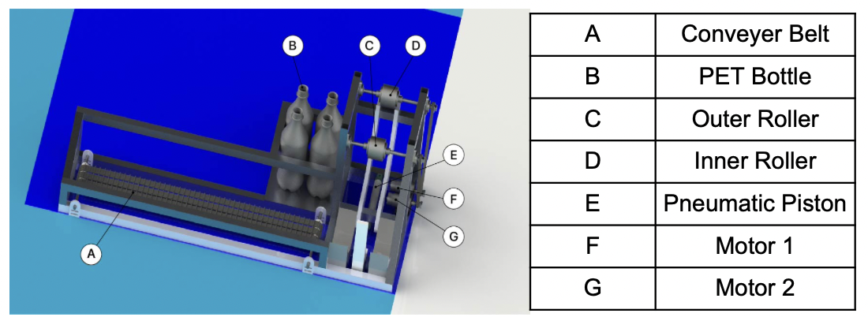

**Fig. 2: Loader Assembly**

**Calculations/Justification:**

The velocity of the ball required to pass it into the shooting mechanism is **1.72m/s(660rpm)**. So the total energy of the system will be:

***E = Kinetic Energy + Compression Energy + Energy lost in friction***

The total energy comes out to be **0.45J**. Since the speed of both the rollers should be equal to launch velocity when the ball comes in contact with the inner roller, using the **Momentum Conservation equation** on ball and roller:

***(Iroller×ωiroller )/Rroller= (Iroller×ωvroller)/Rroller + Mball×Vball + (Iball×ωball)/Rball***

We get the velocity of the outer roller to be **2.62m/s(1000rpm)**. An acceleration of 0 to 1000rpm in **1 sec** is desired so,

***Ꞇ = M.I of outer roller×𝛼 = 0.0212 Nm***

1. **Shooting mechanism:**

The **objective of the task** is to shoot the balls to break the lagori pile and displace the Ball on head. The shooting mechanism consists of 2 systems:

***Axial Rotation system:*** To rotate the shooter assembly axially while tracking the opponent’s R2 robot, a **thin section bearing** is placed in between the loader mechanism and shooter assembly. A pulley is attached to the bearing which is connected to a [**NEMA 17 stepper motor**](https://drive.google.com/file/d/1HYU5g27u10LkDYeDlB7_B2sMhLW5TvR7/view?usp=sharing) [step angle: 1.8°] via belt drive for precise rotation of the shooter assembly. A **rotary encoder** is connected to monitor the rotations of the motor.

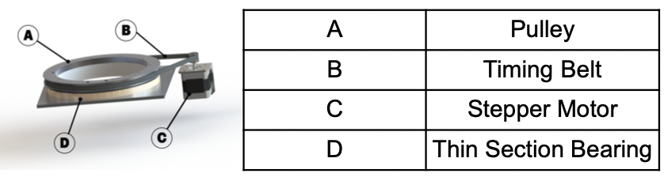

**Fig. 3: Axial Rotation System**

**Justification:**

The rotation of the [**NEMA 17 stepper motor**](https://drive.google.com/file/d/1HYU5g27u10LkDYeDlB7_B2sMhLW5TvR7/view?usp=sharing)is governed by the output from the **camera,** which is mounted on top of the shooting assembly and used to track the position of the ball on head.

***Flywheel Shooter:*** A flywheel of mass **1kg** and diameter **10cm** rotating at a **fixed angular velocity** is used to shoot the ball. The flywheel compresses the ball by 2mm against the adjuster which gives a **negative spin** to the ball. The flywheel is connected to a pulley by a shaft which in turn is connected to [**RS-775 DC geared Motor**](https://drive.google.com/file/d/1CAsGtIlop2uaRkpFcW5WMByKI5k62SSh/view?usp=sharing) by a **timing belt**. An angle adjuster guides the ball out of the shooting mechanism whose position is governed by the combined output from the **Camera and Lidar Sensor.** The angle adjuster sweeps an angle of 45° and is actuated by a [**Nema 17 stepper motor**](https://drive.google.com/file/d/1umrMaxWtnW_YR3de4JZY6niyp19-33jr/view?usp=sharing) which is connected to the back of the angle setter replicating a gear like behaviour.

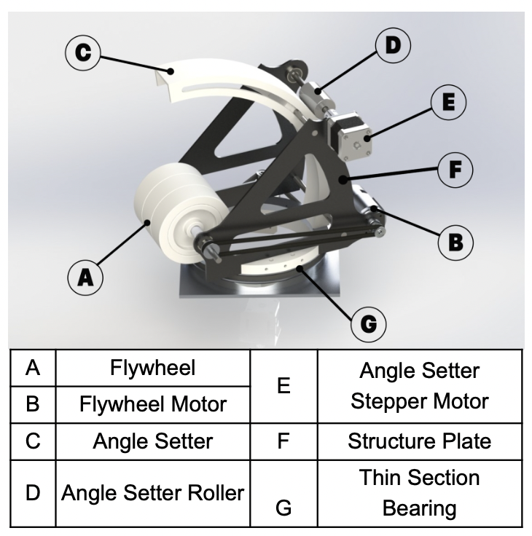

**Fig. 4: Shooter Assembly**

**Calculations/Justification:**

After simulation and optimization, it was concluded that the shooting speed of the ball should be around 8m/s to break the lagori pile (which is less than 30km/h as mentioned in **rule 2.1.10**) and displace the ball on head at a maximum playable distance. Using **Momentum conservation equation** on ball and flywheel:

***Iflywheel×ωiflywheel = Iflywheel×ωvflywheel + Mball×Vball + Iball×ωball***

We get the final velocity of the flywheel as 23.44m/s (4477 rpm). The total energy of the flywheel is be given by:

***E = ×I×ω2 = 61.685 J***

The flywheel will lose 44% of its energy after it shoots the ball. Considering the time required to come back to its initial state to be 2.5 sec, the torque comes out to be:

***Ꞇ = M.I of flywheel × 𝛼 = 0.158 Nm***

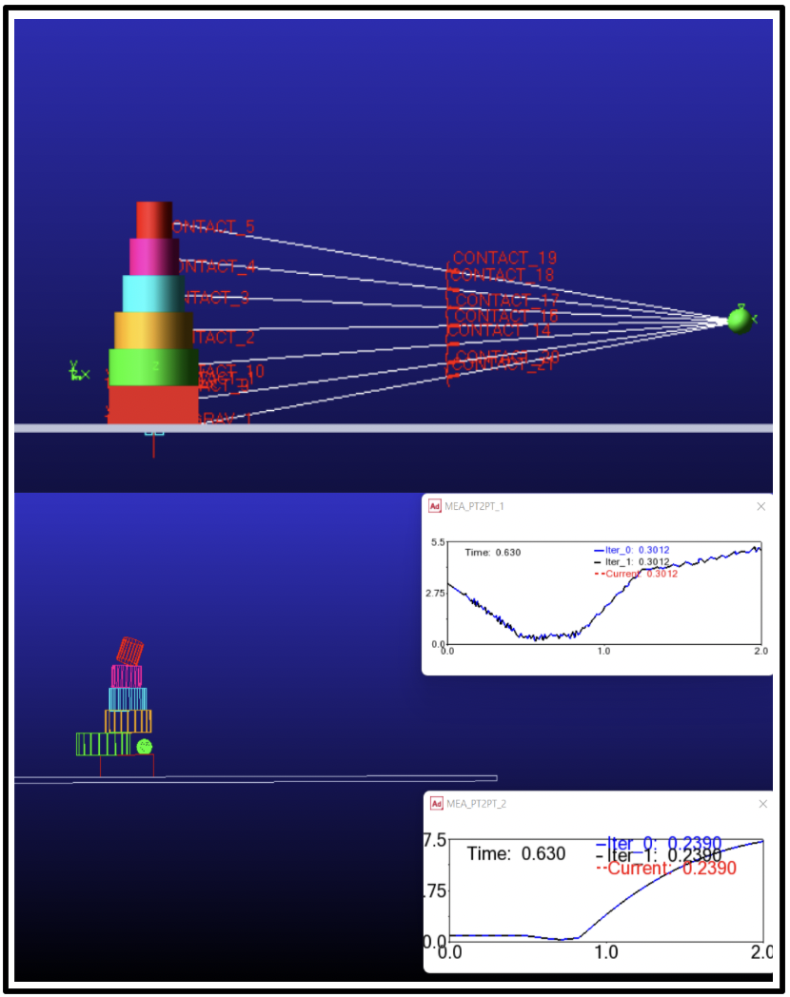

**Fig. 5: Simulation from Adams**

Hence a motor with **3055 rpm and 0.158 Nm** torque having a **power output of 12.33W** is required. So [**RS-775 DC geared Motor**](https://drive.google.com/file/d/1CAsGtIlop2uaRkpFcW5WMByKI5k62SSh/view?usp=sharing) has been taken and reduction has been provided to it to attain the desired characteristics. As the RPM of the motor can be controlled electronically, it can be optimised differently for lagori breaking and displacing the ball on head.

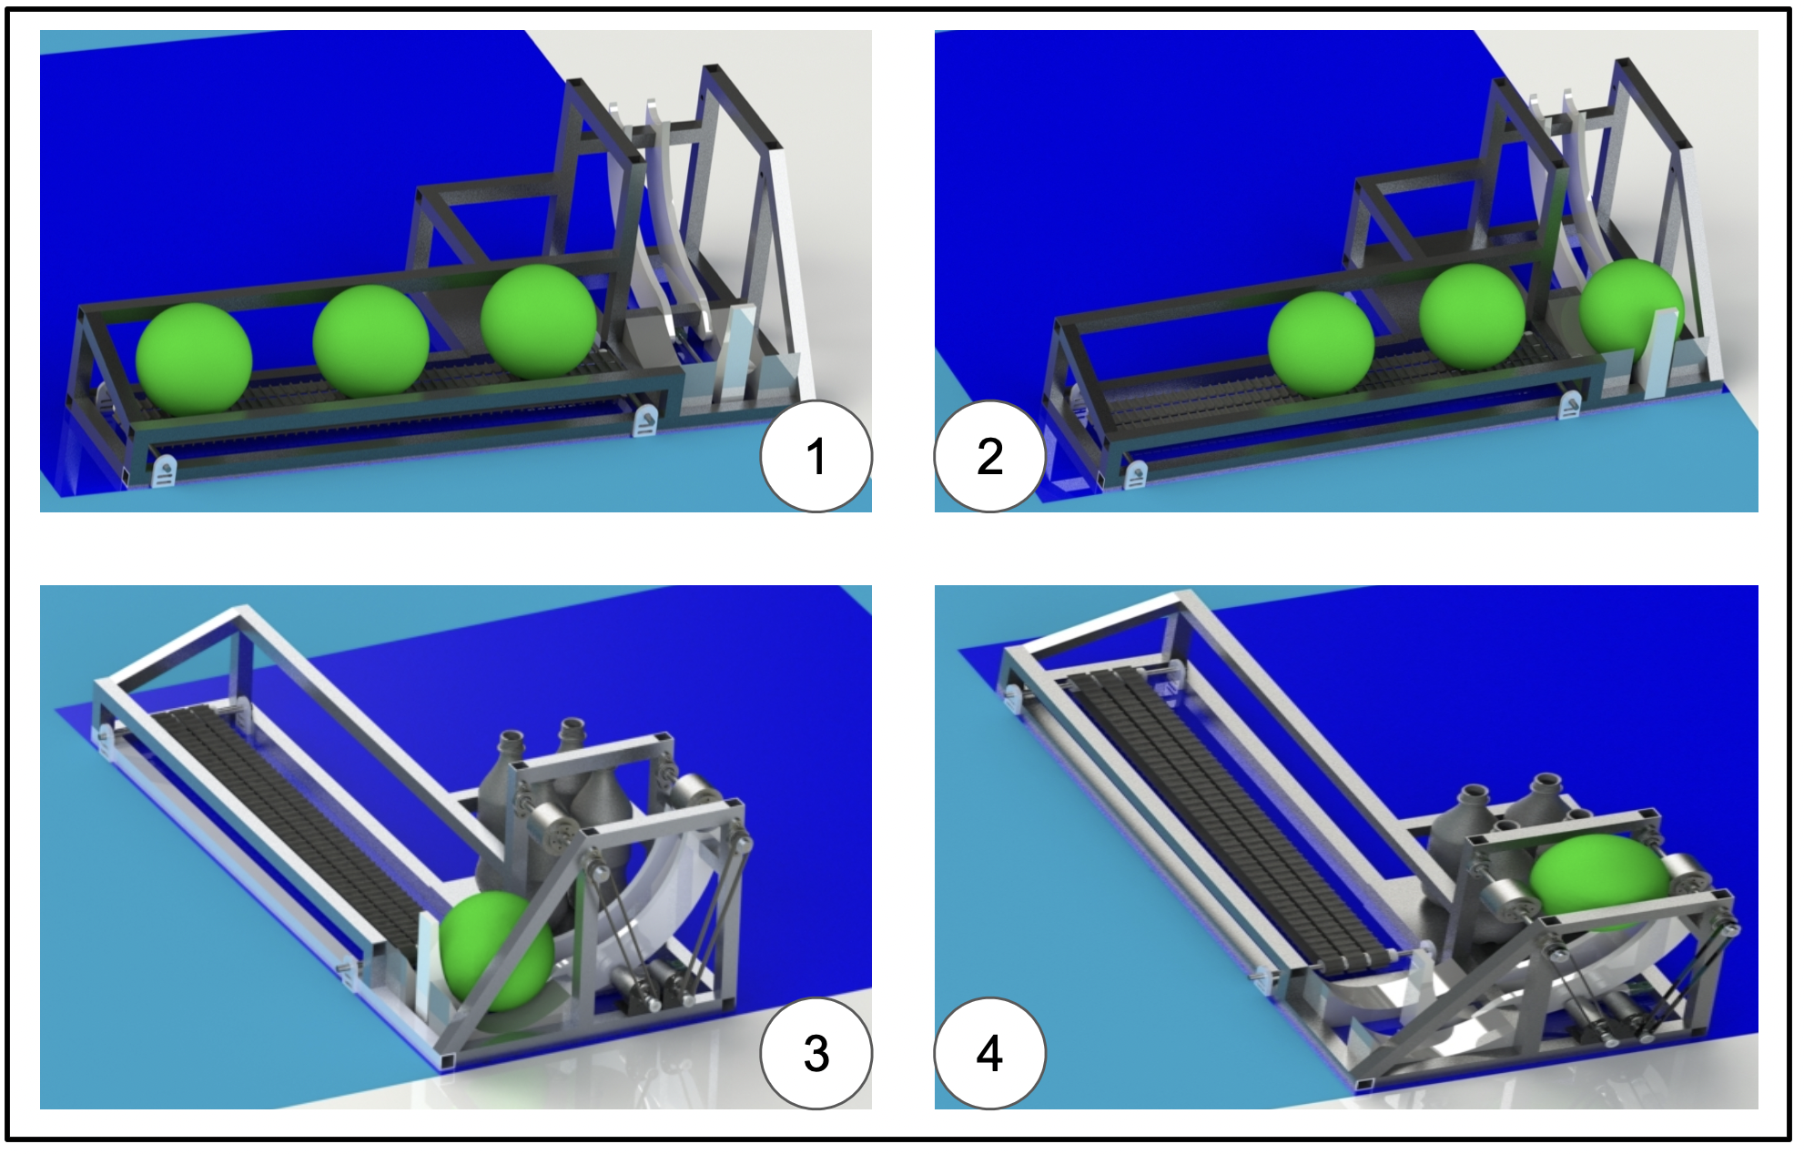

**Fig. 6: Ball Loading**

**2. ROBOT R2:**

* **Overall Dimensions (LxWxH) in** **mm:**

**Before the game:** 985*×*944*×*1248

**During the game:** 1200*×*944×1248

* **Material used:** Stainless steel AISI 304, PLA, Aluminium 6061 T4, ABS, Glass Fibre, Carbon Fibre Rods
* **Estimated weight:** 25 kg

**Objective**: The main tasks of the R2 robot includes collecting the ball from the ball rack, passing it to R1, and piling up the lagori discs.

1. **Type of Drive:**

A **Rectangular chassis** of dimensions **787mm*×*542mm**, made of **Aluminium 6061 T4** is used. We have selected a **4-wheel Mecanum Drive** because it solves our purpose of smooth manoeuvrability and gives the robot better traction and weight distribution. The robot is controlled **manually** via a **PS4 controller**. The wheels are actuated using 4[**Planetary DC geared motors [250W 750RPM 18V DC (3.83 Nm)]**](https://drive.google.com/file/d/1wr3CGX9iBzxceTh3Sgqq352VhUwF4zz-/view?usp=sharing). Wheels used are of diameter 203mm.

1. **Ball Picking mechanism:**

As per the game strategy, only R2 will pick-up the balls from the rack, 3 at a time. The picking mechanism consists of **9 rollers** supported on a single shaft, attached to retractable plates at both ends. The rollers are actuated using a [**Johnson Geared Motor [12 V DC 350 RPM]**](https://drive.google.com/file/d/1Jk_DCYbjCCyUdDuIL6Rs92Aq_pmty91C/view?usp=sharing) connected to the shaft using a **belt drive**. A **timing belt (cleat belt)** is used to avoid slippage.

**Working of mechanism:**

1. At the start of the game, the entire ball picking mechanism, along with the ball rack, will be in the **retracted position** as shown in **Fig 8**.
2. To pick the balls from the ball rack, the ball picking assembly will be brought down using a slider arm actuated by two [**Orange OG555 High Torque DC Motor [12V 10RPM 680N-cm]**](https://drive.google.com/file/d/1rM0ssLCpSSKcBx6cHEfzXU7ZBDERYYv2/view?usp=sharing)one attached to each plate,as shown in **Fig 9**.

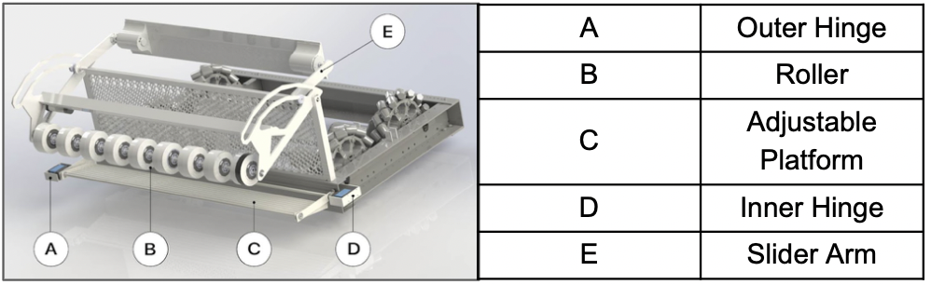

**Fig. 7: Ball Picking Mechanism**

1. An adjustable platform will come out from its retracted position, ready to receive the balls. A net is attached behind the ball rack which prevents the balls from falling off the platform.
2. An [**Orange OT5320M 7.4V 20kg.cm 180° Copper Metal Gear Digital Servo Motor**](https://drive.google.com/file/d/15HYrp_scZDa5uuK6nsqkNKPk4CQDpybI/view?usp=sharing)is connected to the inner hinge of the platform which is used to retract it and another [**Orange OT5320M 7.4V 20kg.cm 180° Copper Metal Gear Digital Servo Motor**](https://drive.google.com/file/d/15HYrp_scZDa5uuK6nsqkNKPk4CQDpybI/view?usp=sharing) connected to its outer hinge is used to tilt it.

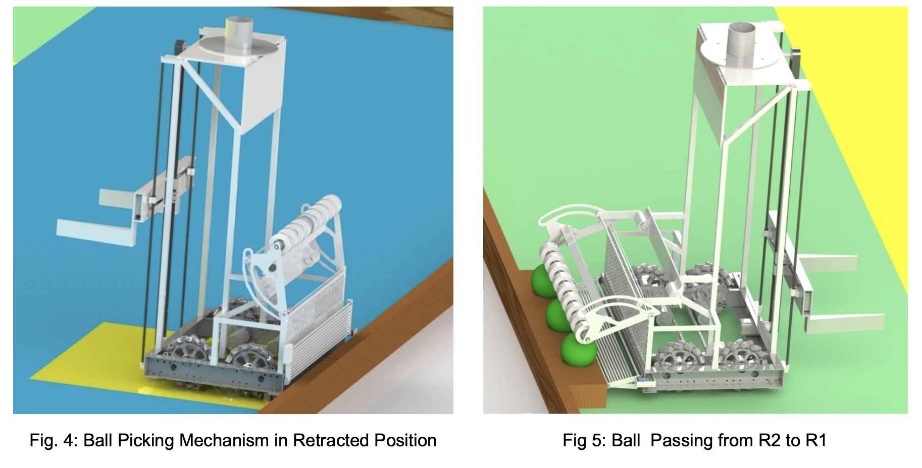

| **Fig. 8: Ball Picking Mechanism in retracted position.** | **Fig. 9: R2 picking balls from the rack.** |
| --- | --- |

**Calculations/Justification:**

The weight of the ball picking mechanism is 5.7kg (using SolidWorks Evaluation). The torque on each motor for actuating the mechanism will be:

***Ꞇ = F×R = 4.18775 Nm***

So, motors of **4.18775 Nm** torqueare required. The total weight of the rollers is 1.71kg. Using **Energy conservation equation** on rollers:

**m×g×𝚫h = 6×m×R2 × *⇒ 𝝎 = 135.83 RPM***

So a [**Johnson Geared Motor [12 V DC 350 RPM]**](https://drive.google.com/file/d/1Jk_DCYbjCCyUdDuIL6Rs92Aq_pmty91C/view?usp=sharing) is used to actuate the rollers.

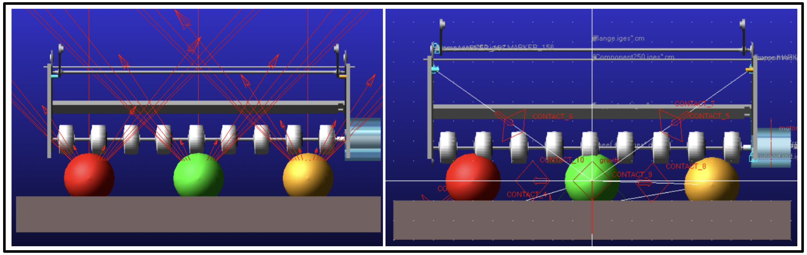

**Fig. 10: Ball Picking Analysis on Adams**

1. **Ball Passing Mechanism:**

The R2 robot will align itself to the receiving part of R1 using [**Sharp sensors [Range 10 - 80 cm]**](https://drive.google.com/file/d/1pfAoHf825rLa8Dv93OQ75UF-czKsddBZ/view?usp=sharing)**.** To pass the balls onto the receiving mechanism of R1, the platform will tilt upwards to drop the balls in the R1’s receiving conveyors. The operator will use the sensor output for aligning the platform accurately.

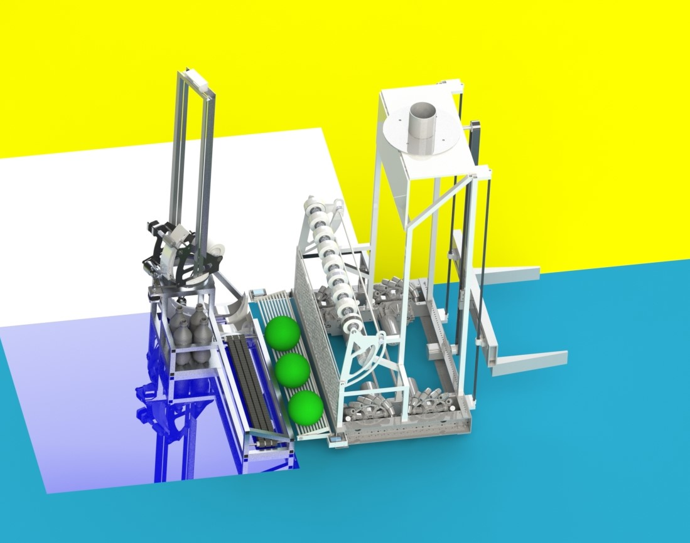

**Fig. 11: Ball passing from R2 to R1**

1. **Lagori Picking and Piling:**

The objective is to pick up the lagori discs and stack them on top of each other on a wooden box. A single **claw** is used for this purpose. A **Rack and Pinion** mechanism is used to expand and contract the grippers. The gripper arms are screwed to the racks and a single pinion is actuated using [**NEMA17 5.6 kg-cm Stepper Motor.**](https://drive.google.com/file/d/1HYU5g27u10LkDYeDlB7_B2sMhLW5TvR7/view?usp=sharing) The claw is attached to a vertical belt drive connected to a [**NEMA 23 18.9 kg-cm Hybrid Stepper Motor**](https://drive.google.com/file/d/1IeF-CIH7aCacOWv4dp8dRJhkKetUCIBm/view?usp=sharing)at its one end for its vertical motion. The maximum height of the belt drive is 1186 mm. The claw is attached to 2 parallel **Carbon Fibre Rods** to support the vertical motion. While piling the lagori, two [**Sharp sensors [Range 10 - 80 cm]**](https://drive.google.com/file/d/1pfAoHf825rLa8Dv93OQ75UF-czKsddBZ/view?usp=sharing) are used for aligning the bot with the wooden box.

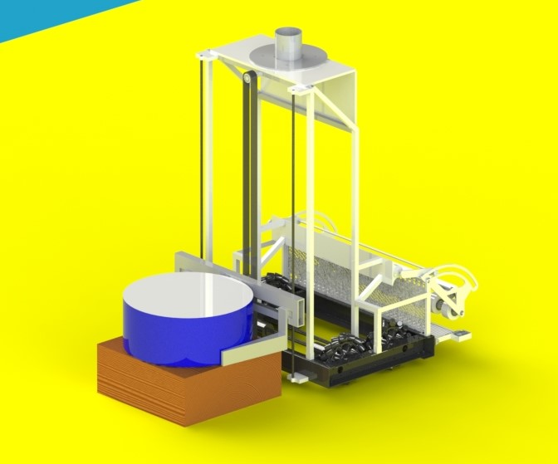

**Fig. 12: Lagori Placing**

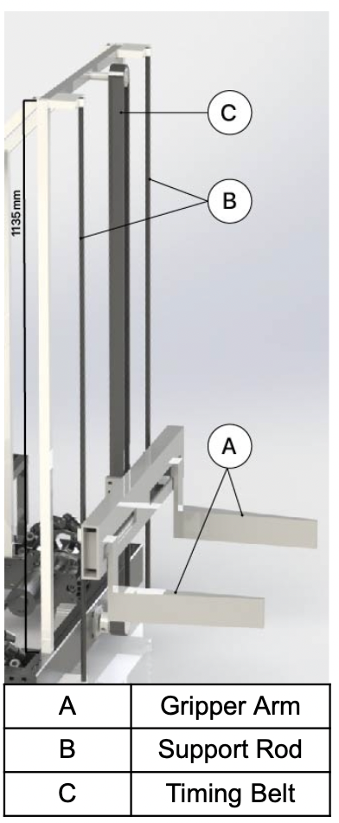

**Fig. 13: Lifting Mechanism**

**Calculations/Justification:**

For the vertical motion of the claw, a single motor attached to the bottom pulley is used. The claw has to travel a vertical distance of 1.18 m in 4 sec.

**V = 0.295m/s**

***N = $\frac{v×60}{2×π×r}$ = 136rpm***

The mass of the claw is **5kg**(from SolidWorks mass properties).

***Ꞇ = m×g×R = 1.015 Nm***

So a [**NEMA17 5.6 kg-cm Stepper Motor**](https://drive.google.com/file/d/1HYU5g27u10LkDYeDlB7_B2sMhLW5TvR7/view?usp=sharing) is used. The claw will have a friction grip. So, the minimum gripping force (on bottom lagori) required would be:

***F = $\frac{m×g}{μ}$ = 4.496 N***

The gripping force must be slightly more than 4.49 N to avoid slippage.

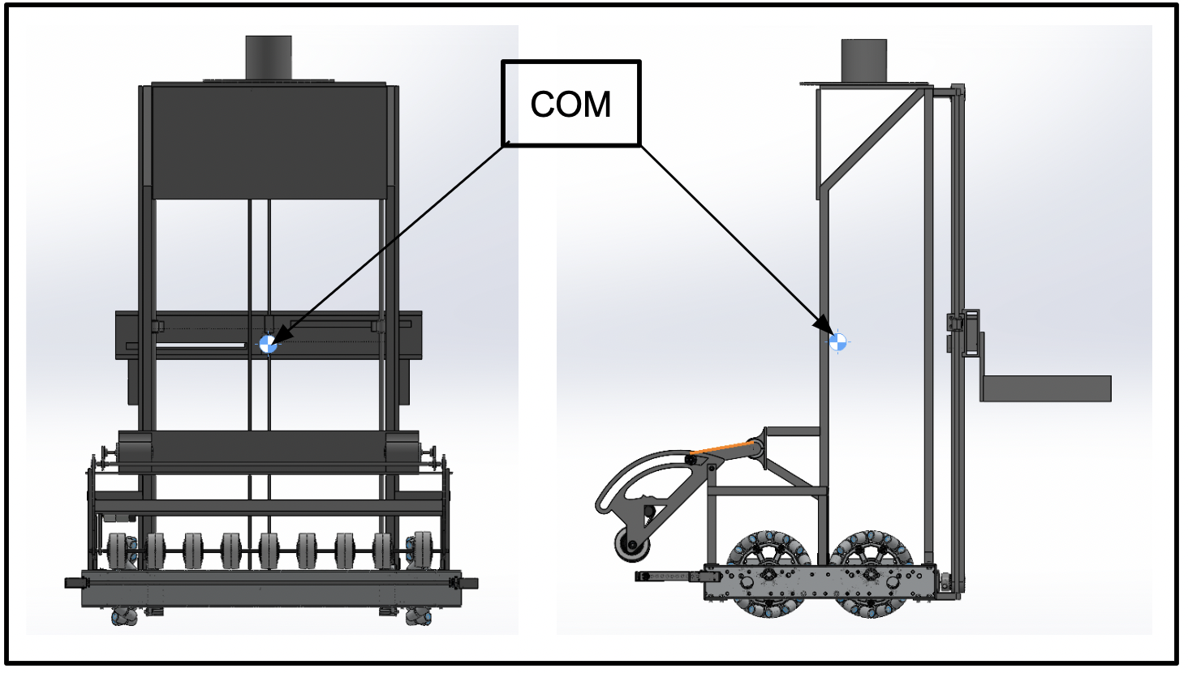

**Fig. 14: Analysis of Centre of Mass of R2 bot**

The R2 robot's structural stability was inferred by calculating the centre of mass in Solidworks.

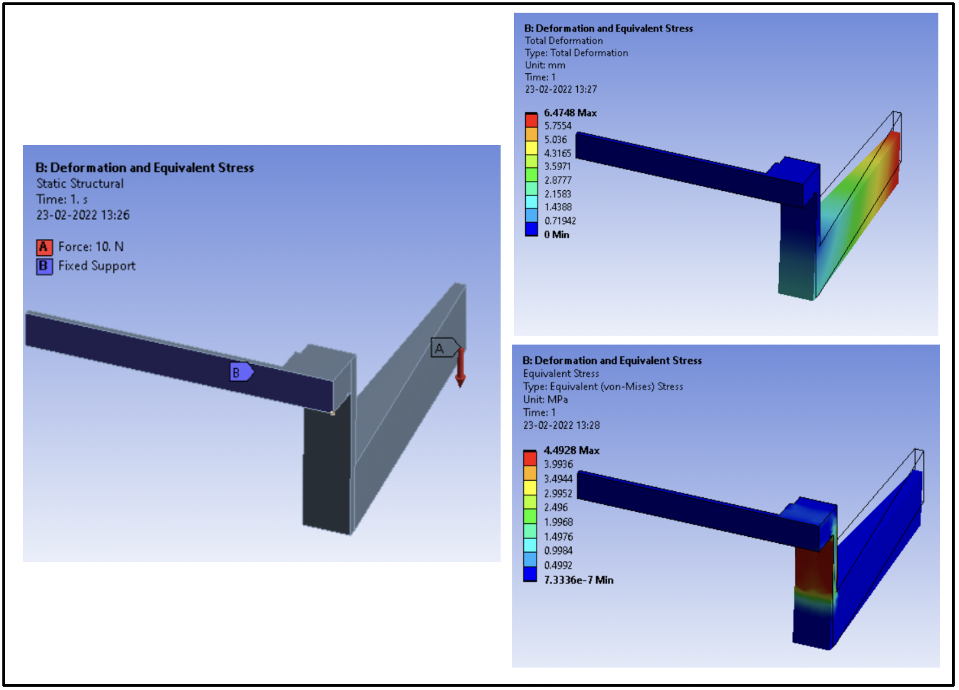

**Fig. 15: Stress & Deformation Analysis of Claw**

The design of the claw was validated by analysis. The highest deformation was **6.4 mm**, and the maximum stress was **4.49 MPa** which is well within accepted range.

**END OF DOCUMENT**